First Name | Last Name | E-Mail
Lara | Boleslawsky | lboleslawsky@gmail.com
Keiko | Honda | hondakeiko@gmail.com
Debra | Sparrow | qwasen@hotmail.com
Haley | Amson | haleyamson@hotmail.com
Terry | Beitz | terrylb@shaw.ca
Meg | Brown | meg_brown@telus.net
Aixendora "LenLen" | Castro | aixendora@hotmail.com
Jill | Edgar | verlaque@shaw.ca
Josette | Faure | josette.faure@shaw.ca
Kathy | Guild | kathyguild@gmail.com
Bobbie | Holden | reholden@gmail.com
Barbara | Jaquith | barbarajaquith@aol.com
Ann | Kent | catkingardens@telus.net
Rosie | Kirschbaumer | rosieker@msn.com
Dawn | Liverd | ko.misti@gmail.com
Czarina | Lobo | czarinal@yahoo.com
Yvonne | Marcus | yvonnemarcus@shaw.ca
Doreen | Oke | daoke@mail.ubc.ca
Henriette | Orth | henrietteorth@gmail.com
Ji-Young | Park | saa890118@gmail.com
Gail | Podmore | gpodmore@shaw.ca
Donna | Ray | donnainauz60@gmail.com
Valerie | Reed | vareed@shaw.ca
Ida | Ryan | iryan@telus.net
Saskia | Stomps | saskiastomps@telus.net
Jeremie | Tucker | Jeremie.tucker@gmail.com
Anne | Vulliamy | avulliamy@shaw.ca
Jane | Witt | wittsend@shaw.ca
Christina | Yan-Lee | chrisyanlee8@hotmail.com
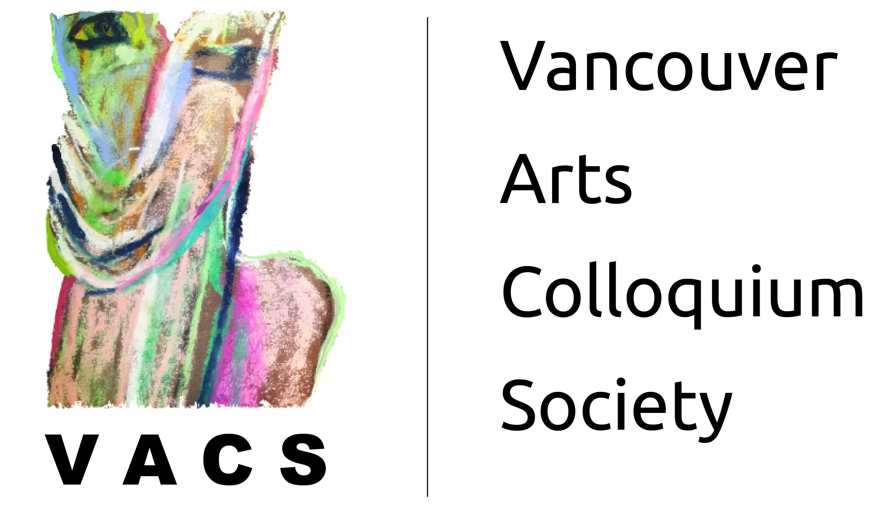
Creative Weaving Workshop
Participants & Contact Info

