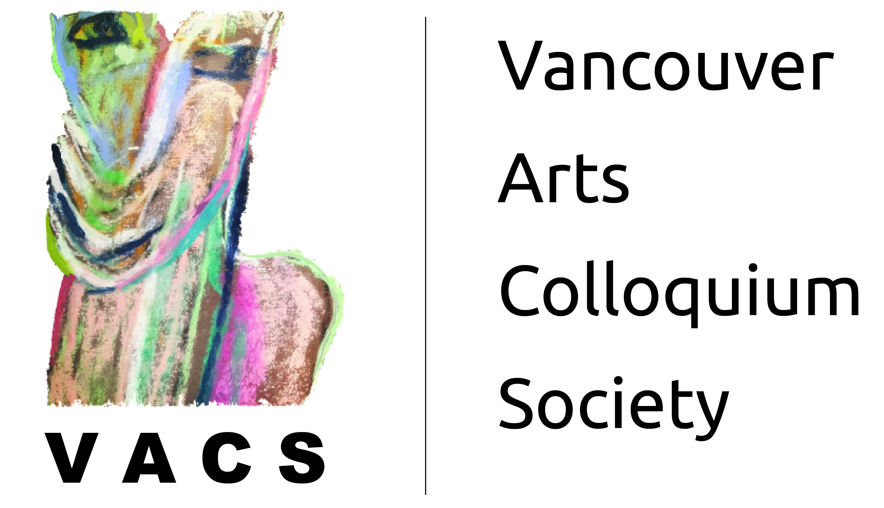
Upcycling Fabrics Workshop
Participants & Contact Info
First Name | Last Name | E-Mail
Lara | Boleslawsky | lboleslawsky@gmail.com
Colleen | Rhodes | meinsdesigns@gmail.com
Dawn | Liverd | ko.misti@gmail.com

